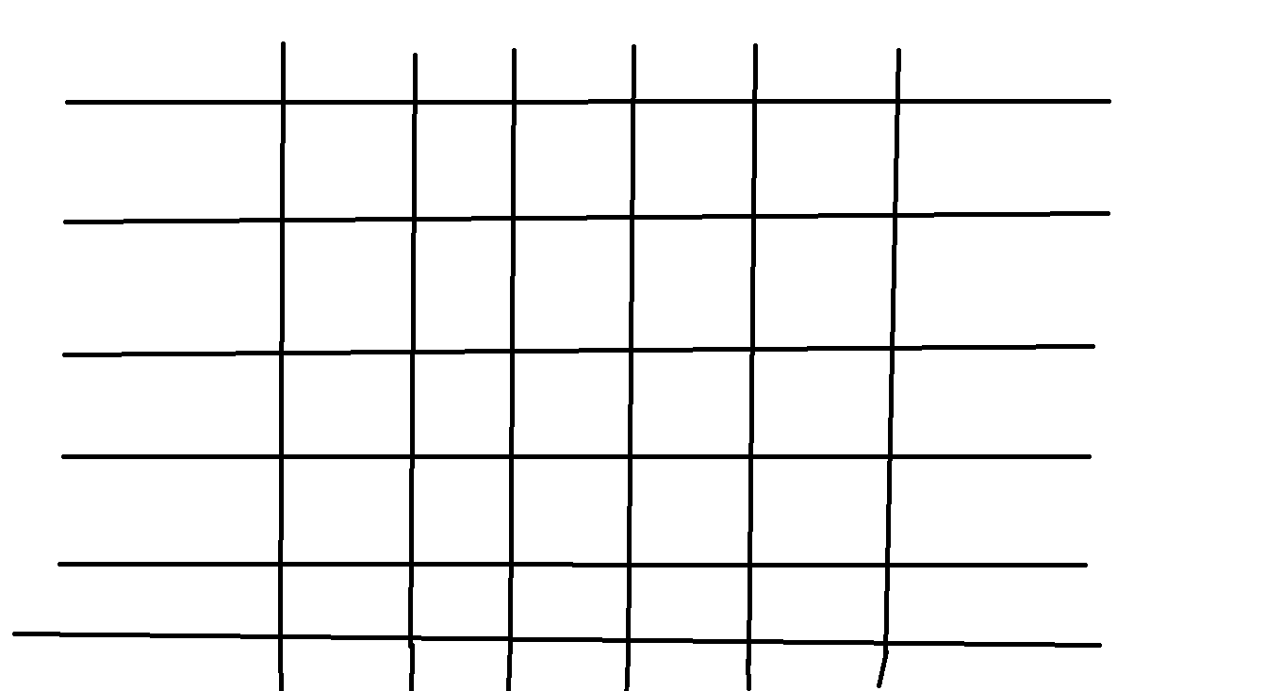

Tic Tac Bro

By Ben Ross

**Abstract:**

Tic Tac Bro is a variation of the classic game Tic Tac Toe. Tic Tac Bro expands on the original game with 2 main features. First the board has been increased to a 7x7 grid rather than a 3x3 in order to promote length but also more ways to win. The player count has also been increased to 3 to help avoid ties and accommodate the larger board while also adding a layer of strategy to the game.

**Materials**

All that is needed is a piece of paper to draw the board as well as the 3 players aiming to play

**Rules**

Tic Tac Bro is a 3-player game with each player choosing X, O,

1. The rules of the game are incredibly simple, the players take turns placing their symbol on the board hoping to achieve a line of 4 in a row to win the game.
2. Players are allowed to place their symbol on any of the 49 squares as long as there is no other symbol currently occupying said space.
3. Once the first player has achieved an unbroken line of 4 symbols in a row the remaining two players continue play until a 2nd and 3rd place has been settled.
4. 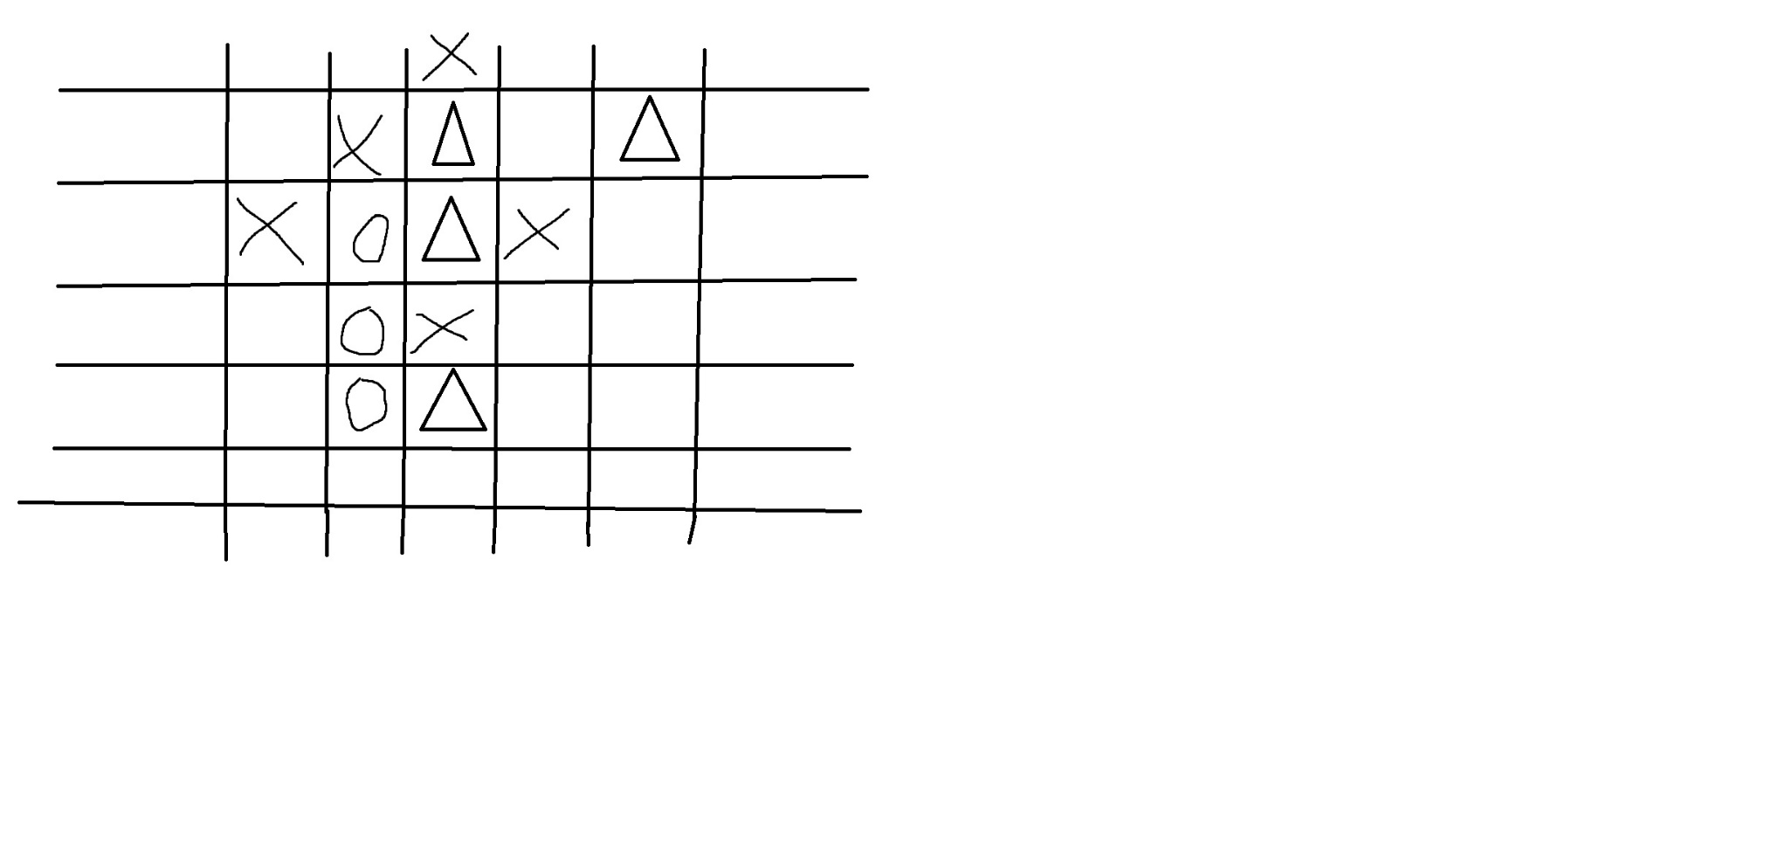In the event of a three way tie there will be no winner.

**Design Process**

I modified the classic game Tic Tac Toe which in my opinion has some pretty large problems with it. When decided which game to modify I went through games often played in passing or games I played a lot as a kid. I was thinking everything from Connect4 to Jenga but decided Tic Tac Toe was something much easier to modify while also easily accessible given all I need is a piece of paper.

There is one glaring problem with Tic Tac Toe and it is a problem that I find quite annoying in games. Unless one is terrible inept in the arts of Tic Tac Toe it is basically impossible to lose the game. The most common result of the game is a draw. This is because of flaws of only having 9 spaces available and the problem of 2 players. In original TTT if player one places X on any corner square, they are in a position to either win or draw no the game unless a horrible misplay is made. Being in a winning position just by nature of going first is a problem in game design that seems most egregious in a game like Tic Tac Toe. If player one has made the right move to start of the game player 2 only has one job in order to realistically draw the game. By playing circle anywhere but the center of the board player 2 is now able to most definitely draw the game once again barring any egregious mistakes. My main goal was to eliminate drawing as much as possible while also allowed for more strategic decision making in the placement of symbols.

When coming up with ways to make the game more strategic while also allowing for longer more dynamic play my first thoughts were to expand the board to a larger scale. A 4x4 board up to a 6x6 board allowed for either too many opportunities for a quick or one sided win which takes away from the idea of putting a strategy behind the movement decisions. I finally prototyped a 7x7 board of normal tic tac toe with a friend online and realized that having 2 players on a larger board feels strange and so we invited a 3rd friend to come join us. Having three players adds a completely new dynamic to the game as an unintended consequence but nonetheless very enjoyable. We found through playing that there would often be situations where 2 players would have to collectively decide to screw a 3rd player out of the win in order to promote their own strategy. By adding a third player we were able to have a much more enjoyable time while also expanding on a game that is incredible simple at its core.

Overall I was able to revamp tic tac toe into something more nuanced that required some semblance of strategic thought and took out the conditions that flawed the game originally.